BÀI TẬP THỰC HÀNH LẬP TRÌNH CĂN BẢN

Bài 1:

#include <iostream>

using namespace std;

int main(){

cout << "************************\n";

cout << "* THAO CHUONG BANG * \n";

cout << "* NGON NGU C * \n";

cout << "************************\n";

return 0;

}

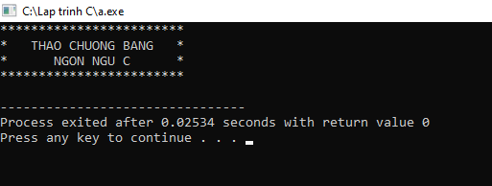

Bài 2:

#include <iostream>

using namespace std;

int main(){

int nam_nay= 2023, nam_sinh, tuoi;

cout<<"Nam sinh cua ban la\n";

cin>>nam_sinh;

tuoi= nam_nay - nam_sinh;

cout<<"ban sinh nam "<<nam_sinh;cout<<" vay tuoi cua ban la "<<tuoi;

}

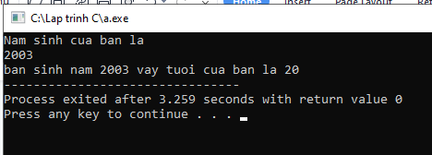

Bài 3:

#include <iostream>

using namespace std;

int main()

{

int LuaChon;

cout << "Nhap 0 de doi tu ky tu sang ma ASCII\nNhap 1 de doi tu ma ASCII sang ky tu\n";

cin >> LuaChon;

if(LuaChon == 0){

char m;

cout<<"Nhap ky tu can doi \n";

cin >> m;

cout <<"Ky tu do trong bang ASCII co gia tri la\n" <<int(m);

return 0;

}

else{

if (LuaChon == 1){

int n;

cout<<"Nhap ma ASCII can doi \n";

cin >> n;

cout <<"Ky tu duoc doi la\n" <<char(n);

return 0;

}else{cout<<"Chi co lua chon 1 hoac 0";

return 0;

}

}

}

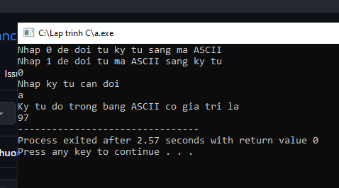

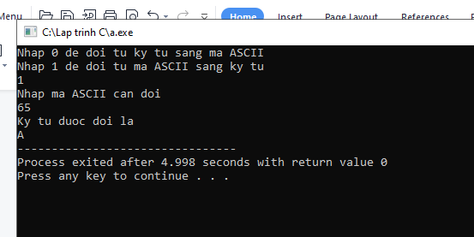

Bài 4:

#include <iostream>

using namespace std;

int main(){

float BanKinh, ChuVi, DienTich;

const float Pi=3.1415;

cout<<"Ban kinh duong tron la\n";

cin>>BanKinh;

ChuVi= 2*Pi*BanKinh;

DienTich= Pi*BanKinh*BanKinh;

cout<<"Chu vi duong tron co ban kinh "<<BanKinh;

cout<<"la "<<ChuVi;

cout<<"\nDien tich duong tron co ban kinh "<<BanKinh;

cout<<"la "<<DienTich;

}

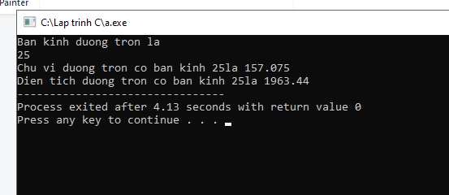

Bài 5:

#include <iostream>

using namespace std;

int main(){

int a,b, max, min;

cout<<"Nhap lan luot 2 so nguyen \n";

cin>>a;

cin>>b;

if (a>b){

cout<<"max="<<a;

cout<<"\nmin= "<<b;

}

else{

cout<<"max= "<<b;

cout<<"\nmin= "<<a;

}

}

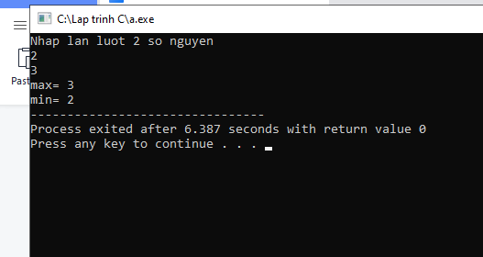

Bài 1 Ứng dụng:

#include <iostream>

using namespace std;

int main(){

float BanKinh, DienTich, TheTich;

const float Pi=3.1415;

cout<<"Ban kinh hinh cau la\n";

cin>>BanKinh;

DienTich= 4*Pi*BanKinh*BanKinh;

TheTich= Pi*BanKinh*BanKinh*BanKinh*4/3;

cout<<"Dien Tich co ban kinh "<<BanKinh;

cout<<"la "<<DienTich;

cout<<"\nThe tich duong tron co ban kinh "<<BanKinh;

cout<<"la "<<TheTich;

}

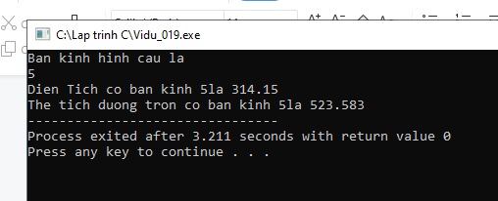

Bài 2 Ứng dụng:

#include <iostream>

#include <math.h>

using namespace std;

int main(){

float x1, y1, x2, y2, HeSoGoc, KhoangCach;

cout<<"Nhap toa do 2 diem lan luot la\nx1,y1\nx2,y2 \n";

cin>>x1;

cin>>y1;

cin>>x2;

cin>>y2;

HeSoGoc=(y2-y1)/(x2-x1);

KhoangCach= sqrt((y2-y1)*(y2-y1)+(x2-x1)*(x2-x1));

cout<<"He so goc cua duong thang di qua hai diem do la "<<HeSoGoc;

cout<<"\nKhoang cach giua hai diem la "<<KhoangCach;

}

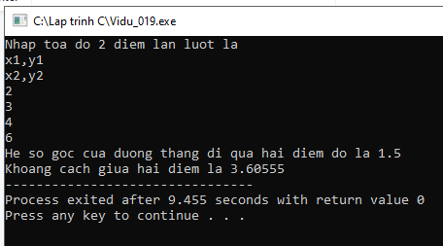

Bài 3 Ứng dụng:

#include <iostream>

using namespace std;

int main()

{

int LuaChon;

cout << "Nhap 0 de doi tu ky tu sang ma ASCII\nNhap 1 de doi tu ma ASCII sang ky tu\n";

cin >> LuaChon;

if(LuaChon == 0){

char m;

cout<<"Nhap ky tu can doi \n";

cin >> m;

cout <<"Ky tu do trong bang ASCII co gia tri la\n" <<int(m);

cout <<"\nKy tu tiep theo la\n" <<char(int(m)+1);

return 0;

}

else{

if (LuaChon == 1){

int n;

cout<<"Nhap ma ASCII can doi 0-255 \n";

cin >> n;

if(n>255){

cout<<"\n So nam ngoai gioi han ";

}

else{

cout <<"Ky tu duoc doi la\n" <<char(n);

cout<<"\nKy tu ke tiep la\n"<<char(n+1);

}

}

else{cout<<"Chi co lua chon 1 hoac 0";

return 0;

}

}

}

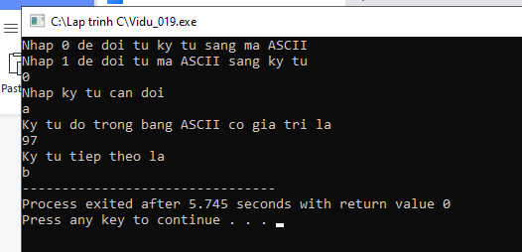

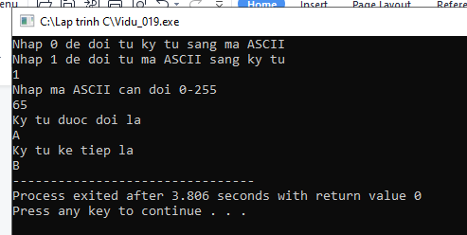

Bài 4 Ứng dụng:

#include <iostream>

using namespace std;

int main(){

float r1, r2, r3, rtd;

cout<<"Nhap r1, r2, r3 lan luot la: \n";

cin>>r1;

cin>>r2;

cin>>r3;

rtd= 1/(1/r1+ 1/r2+ 1/r3);

cout<<"Tong tro tuong duong la: "<<rtd;

return 0;

}

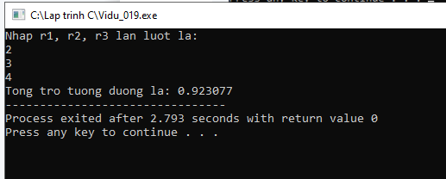

Bài 8 Ứng dụng:

#include <iostream>

using namespace std;

int main(){

int ThoiGian, Gio, Phut, Giay;

cout<<"Nhap thoi gian cong viec tinh bang giay\n";

cin>>ThoiGian;

if(ThoiGian>3600){

Gio= ThoiGian/3600;

Phut= (ThoiGian%3600)/60;

Giay= ThoiGian-Gio*3600-Phut*60;

cout<<" "<<Gio; cout<<"gio "<<Phut ; cout<<"phut "<<Giay; cout<<"giay ";

}

else{

if(ThoiGian>60){

Gio=0;

Phut= ThoiGian/60;

Giay= ThoiGian%60;

cout<<" "<<Gio; cout<<"gio "<<Phut ; cout<<"phut "<<Giay; cout<<"giay ";

}

else{

Gio=0;

Phut=0;

Giay= ThoiGian;

cout<<" "<<Gio; cout<<"gio "<<Phut ; cout<<"phut "<<Giay; cout<<"giay ";

}

}

}

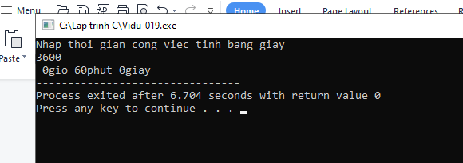

Bài 9 Ứng dụng:

#include <iostream>

using namespace std;

int main(){

int ThoiGian, Gio, Phut, Giay;

cout<<"Nhap thoi gian cong viec tinh bang giay\n";

cin>>ThoiGian;

if(ThoiGian>3600){

Gio= ThoiGian/3600;

Phut= (ThoiGian%3600)/60;

Giay= ThoiGian-Gio*3600-Phut*60;

cout<<" "<<Gio; cout<<":"<<Phut ; cout<<":"<<Giay;

}

else{

if(ThoiGian>60){

Gio=0;

Phut= ThoiGian/60;

Giay= ThoiGian%60;

cout<<"0"<<Gio; cout<<":"<<Phut ; cout<<":"<<Giay;

}

else{

Gio=0;

Phut=0;

Giay= ThoiGian;

cout<<"0"<<Gio; cout<<":0"<<Phut ; cout<<":"<<Giay;

}

}



